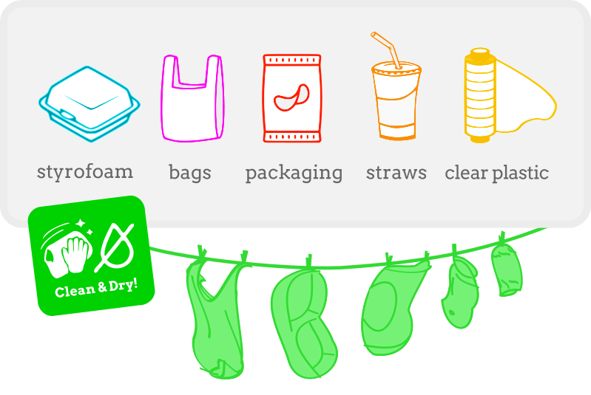
Tips for Making Eco bricks
1. Save clean and dry plastics that you can’t recycle. If there is any food, oil or dirt on your plastic, make sure you wash and dry it or it might go mouldy in your bottle.

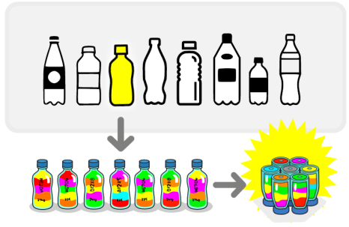
2. Choose the type of bottle you want to use. Using the same size and shape of bottle makes it easier to build with your ecobricks later. Pick a type of bottle that you use a lot anyway.

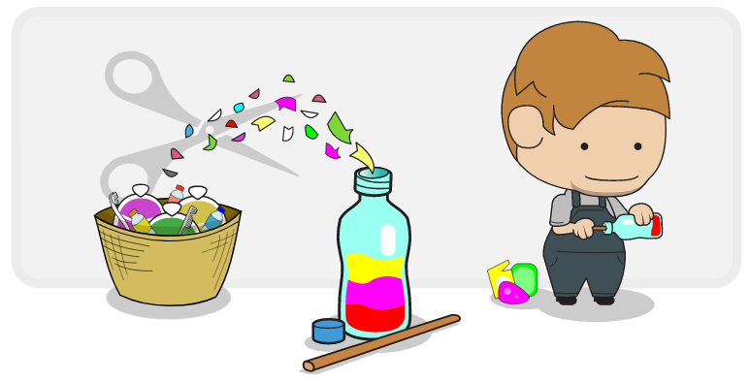
3. Choose your packing stick. It’s your magic wand and makes the plastic disappear! Bamboo and wood make the best sticks.

4. Pack the bottle tightly, mixing plastics as you go. Cut or rip up large plastics into smaller pieces. The smaller the pieces, the tighter you’ll pack! Use your stick to push down around the sides of the bottle.

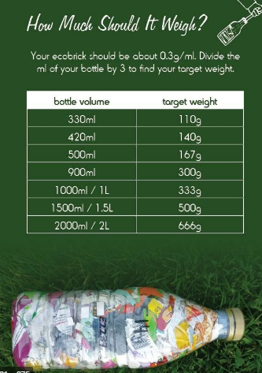

5. Weigh your bottle as you go – these are the weights you’re aiming for…
6. Save up your bricks.
7. Have a look on-line at some of the things you could make with your bricks - there are loads of ideas!

